TASK 1
PROGRAM:

import time
from decimal import Decimal, ROUND_HALF_UP

BASE_RATE = Decimal("30.00") # Rs per litre at standard quality
STD_FAT = Decimal("3.5") # standard fat %
STD_SNF = Decimal("8.5") # standard SNF %
STEP = Decimal("0.1") # rate changes in steps of 0.1 %
FAT_ADJ = Decimal("0.40") # Rs per 0.1 % fat above/below standard
SNF_ADJ = Decimal("0.30") # Rs per 0.1 % SNF above/below standard
FAT_MIN, FAT_MAX = Decimal("2.0"), Decimal("7.0") # given in the problem
SNF_MIN, SNF_MAX = Decimal("6.0"), Decimal("10.0") # assumption
MAX_LITRES = Decimal("500") # assumption: catches typos like 1250 for 12.5
SHIFTS = ("M", "E") # Morning / Evening
PAISA = Decimal("0.01")

def validate_entry(farmer_id, shift, litres, fat, snf):
"""Return a list of rule violations (empty list means valid)."""
errors = []
if not farmer_id.strip():
errors.append("Farmer ID is empty")
if shift not in SHIFTS:
errors.append("Shift must be M or E")
if not (0 < litres <= MAX_LITRES):
errors.append("Litres must be > 0 and <= 500")
if not (FAT_MIN <= fat <= FAT_MAX):
errors.append("Fat must be between 2.0 and 7.0")
if not (SNF_MIN <= snf <= SNF_MAX):
errors.append("SNF must be between 6.0 and 10.0")
return errors

def rate_per_litre(fat, snf):
"""Rate per litre in Rs, from fat % and SNF %."""
fat_steps = (fat - STD_FAT) / STEP
snf_steps = (snf - STD_SNF) / STEP
return BASE_RATE + fat_steps * FAT_ADJ + snf_steps * SNF_ADJ

def entry_amount(litres, fat, snf):
"""Amount for one entry, rounded once (half-up) to the paisa."""
return (litres * rate_per_litre(fat, snf)).quantize(PAISA, rounding=ROUND_HALF_UP)

def process_entries(raw_entries):
"""Validate and price all entries; return dict of ten-day totals."""
totals = {}
for fid, shift, l, f, s in raw_entries:
litres, fat, snf = Decimal(l), Decimal(f), Decimal(s)
errs = validate_entry(fid, shift, litres, fat, snf)
if errs:
print(f"REJECTED {fid} {shift}: {'; '.join(errs)}")
continue
rate = rate_per_litre(fat, snf)
amt = entry_amount(litres, fat, snf)
totals[fid] = totals.get(fid, Decimal("0.00")) + amt
print(f"{fid} {shift}: {litres} L rate Rs {rate:.2f} amount Rs {amt}")
return totals

raw_entries = [
("F001", "M", "12.5", "4.0", "8.8"),
("F001", "E", "10", "3.5", "8.5"),
("F002", "M", "8.25", "3.2", "8.3"),
("F003", "M", "-5", "3.5", "8.5"), # invalid on purpose
]

print("=== Main design: list of tuples ===")
totals = process_entries(raw_entries)

print("\nTen-day totals")
for fid, t in totals.items():
print(f"{fid}: Rs {t}")
print("\n=== Alternative design: separate variables ===")
litres1, fat1, snf1 = "12.5", "4.0", "8.8"
litres2, fat2, snf2 = "10", "3.5", "8.5"
amt1 = entry_amount(Decimal(litres1), Decimal(fat1), Decimal(snf1))
amt2 = entry_amount(Decimal(litres2), Decimal(fat2), Decimal(snf2))
total_alt = amt1 + amt2 # for n entries: amt1 + amt2 + ... + amtn
print(f"F001 total (separate variables): Rs {total_alt}")
print("Matches main design:", total_alt == totals["F001"])
print("\n=== Timing: O(n) check ===")
for n in (300, 6000, 150000):
data = [("F001", "M", "12.5", "4.0", "8.8")] * n
t0 = time.perf_counter()
for fid, sh, l, f, s in data:
entry_amount(Decimal(l), Decimal(f), Decimal(s))
print(f"n = {n:>6}: {time.perf_counter() - t0:.4f} s")

OUTPUT:
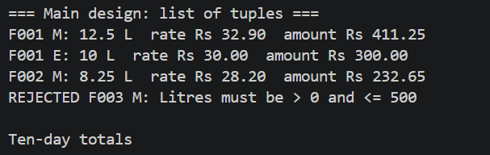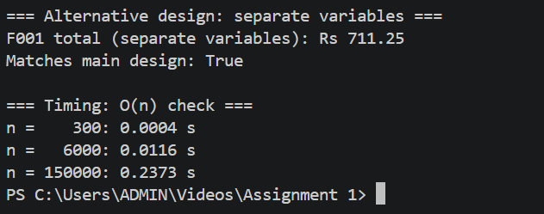

TASK 2
PROGRAM:
TYPES:_
rom decimal import Decimal

print(type(10))
print(type(10.0))
print(type("10"))
print(type(True))
print(type([10, 8.5]))
print(isinstance(True, int))
print(True + 1)
print(10 == 10.0)
print("10" + "10")

print(7 / 2)
print(7 // 2)
print(7 % 2)
print(-7 // 2)
print(-7 % 2)

print(0.1 + 0.2)
print(0.1 + 0.2 == 0.3)
print(Decimal(0.1))
print(Decimal("0.1") + Decimal("0.2") == Decimal("0.3"))

total = 0.0
for amount in [33.40] * 1000 + [0.10] * 3:
total += amount
print(total)
print(round(2.675, 2))
print(3340 * 1000 + 10 * 3)
print(Decimal("33.40") * 1000 + Decimal("0.10") * 3)

TODO 1:
from decimal import Decimal
import sys
import timeit

# 1,000 payments of Rs 33.40 and three small adjustments of Rs 0.10
payments = ["33.40"] * 1000 + ["0.10"] * 3

def total_float(items):
total = 0.0
for amount in items:
total += float(amount)
return total

def total_decimal(items):

total = Decimal("0")
for amount in items:
total += Decimal(amount)
return total

print("float :", total_float(payments))
print("Decimal:", total_decimal(payments))
print(0.1 + 0.2 == 0.3, Decimal("0.1") + Decimal("0.2") == Decimal("0.3"))

def total_decimal_from_float(items):
total = Decimal("0")
for amount in items:
total += Decimal(float(amount))
return total

print("\n--- Decimal(float(amount)) ---")
print("Decimal(float('33.40')) =", Decimal(float("33.40")))
print("Decimal from float total:", total_decimal_from_float(payments))
print("Equals exact 33400.30 ?", total_decimal_from_float(payments) == Decimal("33400.30"))
def total_paise(items):
total = 0 # integer paise
for amount in items:
total += int(Decimal(amount) * 100) # exact string -> paise
return total # e.g. 3340030

def total_float_round(items):
total = 0.0
for amount in items:
total = round(total + float(amount), 2)
return total

p = total_paise(payments)
print("\n--- Alternatives ---")
print("int paise :", p, "-> Rs", f"{p // 100}.{p % 100:02d}")
print("float + round() :", total_float_round(payments))

print("\nsys.getsizeof (bytes):")
print(" float :", sys.getsizeof(33.40))
print(" Decimal:", sys.getsizeof(Decimal("33.40")))
print(" int :", sys.getsizeof(3340))

print("\nTime for the whole loop of 1003 additions (best of 5, 200 runs):")
for name, fn in [("float", total_float), ("Decimal", total_decimal),
("int paise", total_paise), ("float+round", total_float_round)]:
t = min(timeit.repeat(lambda: fn(payments), number=200, repeat=5)) / 200
print(f" {name:12s}: {t*1e6:8.1f} us total, {t/len(payments)*1e9:7.1f} ns per addition")
print("\n--- Types and division operators ---")
print(type(33.40), type(Decimal("33.40")), type(3340))
print("7 / 2 =", 7 / 2, type(7 / 2))
print("7 // 2 =", 7 // 2, type(7 // 2))
print("-7 // 2 =", -7 // 2, "(floors toward -infinity)")
print("7 % 2 =", 7 % 2)
print("0.1 + 0.2 =", 0.1 + 0.2)
print("Decimal('0.1') + Decimal('0.2') =", Decimal("0.1") + Decimal("0.2"))

OUTPUT:
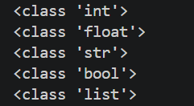
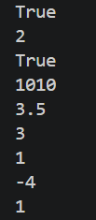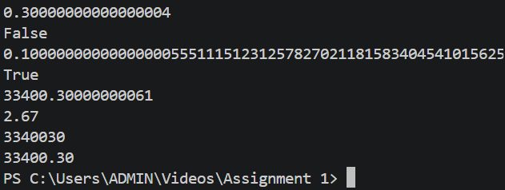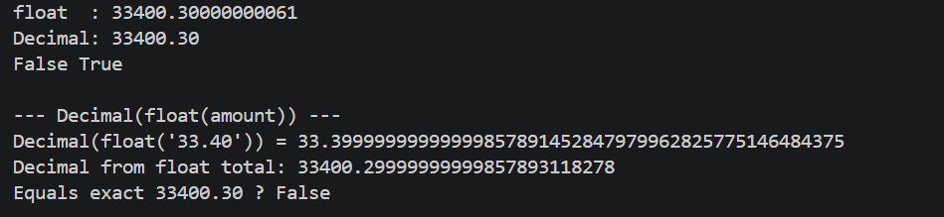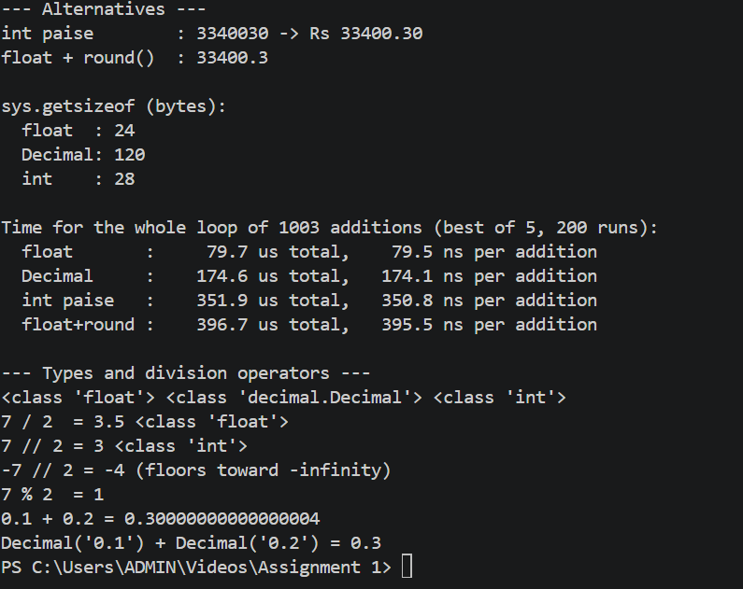

TASK 3
PROGRAM:

PAISE_PER_RUPEE = 100
BASE_RATE_PAISE = 3000 # Rs 30.00 per litre at standard quality
STD_FAT_TENTHS = 35 # standard fat = 3.5 %
STD_SNF_TENTHS = 85 # standard SNF = 8.5 %
FAT_STEP_PAISE = 40 # Rs 0.40 per 0.1 % of fat above/below standard
SNF_STEP_PAISE = 30 # Rs 0.30 per 0.1 % of SNF above/below standard
PAYMENT_DAYS = 10 # farmers are paid every 10 days

MIN_FAT_PCT, MAX_FAT_PCT = 1.0, 10.0
MIN_SNF_PCT, MAX_SNF_PCT = 5.0, 12.0
MAX_LITRES = 500.0

def to_tenths(percent):
"""3.8 -> 38 (round() avoids float errors such as 3.8*10 = 37.99999)."""
return round(percent * 10)

def price_per_litre_paise(fat_pct, snf_pct):
return (BASE_RATE_PAISE
+ (to_tenths(fat_pct) - STD_FAT_TENTHS) * FAT_STEP_PAISE
+ (to_tenths(snf_pct) - STD_SNF_TENTHS) * SNF_STEP_PAISE)

def payment_paise(litres, fat_pct, snf_pct):
return round(litres * price_per_litre_paise(fat_pct, snf_pct)) # round once

def rupees(paise):
sign = "-" if paise < 0 else ""
paise = abs(paise)
return f"Rs {sign}{paise // PAISE_PER_RUPEE}.{paise % PAISE_PER_RUPEE:02d}"

entries = [(10.5, 4.0, 8.8), (20.0, 3.5, 8.5), (8.0, 3.2, 8.3)]
for litres, fat, snf in entries:
p = price_per_litre_paise(fat, snf)
print(f"{litres:5.1f} L fat {fat} snf {snf} rate {rupees(p)}/L "
f"amount {rupees(payment_paise(litres, fat, snf))}")

x = 10
print(x, type(x))
x = "ten"
print(x, type(x))

a, b = 3.5, 8.5
a, b = b, a
print(a, b)
BASE_RATE_PAISE = 3200
print(rupees(price_per_litre_paise(3.5, 8.5)))
OUTPUT:
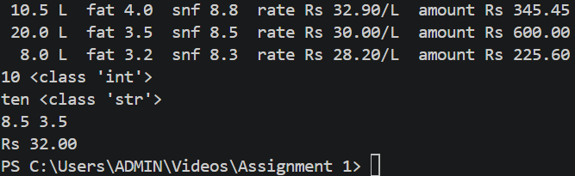

TASK 4
PROGRAM:
import math

BASE_RATE = 30.00 # Rs per litre at base quality
BASE_FAT = 3.5 # base fat %
BASE_SNF = 8.5 # base SNF %
STEP = 0.1 # one step = 0.1 %
FAT_PER_STEP = 0.40 # Rs per fat step
SNF_PER_STEP = 0.30 # Rs per SNF step

def count_steps(value, base):
"""Number of 0.1% steps above (+) or below (-) the base."""
return round((value - base) / STEP) # round() removes float error

def rate_per_litre(fat, snf):
fat_steps = count_steps(fat, BASE_FAT)
snf_steps = count_steps(snf, BASE_SNF)
rate = BASE_RATE + fat_steps * FAT_PER_STEP + snf_steps * SNF_PER_STEP
return round(rate, 2)

def amount(litres, fat, snf):
return round(litres * rate_per_litre(fat, snf), 2)

print("Fat steps for 4.2 :", count_steps(4.2, BASE_FAT))
print("SNF steps for 8.2 :", count_steps(8.2, BASE_SNF))
print("Rate (4.2, 8.5) :", rate_per_litre(4.2, 8.5))
print("Amount 10.5 L :", amount(10.5, 4.2, 8.5))

fat = 4.2
print("Valid fat?", 2.0 <= fat <= 7.0)
OUTPUT: 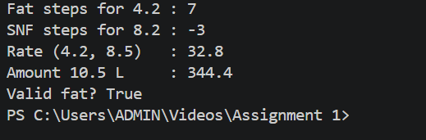
TASK 5
PROGRAM:
import sys
import timeit

BASE_PRICE = 30.00 # Rs per litre at 3.5% fat and 8.5% SNF
BASE_FAT = 3.5
BASE_SNF = 8.5
FAT_RATE = 0.40 # Rs per 0.1% fat above/below base
SNF_RATE = 0.30 # Rs per 0.1% SNF above/below base

# Sensible limits so that typing errors (e.g. 85 instead of 8.5) are caught
LIMITS = {
"Quantity (litres)": (0.1, 200.0),
"Fat %": (0.0, 15.0),
"SNF %": (0.0, 15.0),
}

def is_valid_number(text):
"""True only for plain non-negative decimals like '8', '8.5', '.5', '8.'.
Rejects '8,5', 'eight', '', '-3', '8.5.2', '8_5', 'nan', 'inf'."""
text = text.strip() # remove spaces around the entry
if text.count(".") > 1: # '8.5.2' is not a number
return False
digits_only = text.replace(".", "", 1) # drop the one allowed decimal point
return digits_only.isdigit() # all remaining chars must be 0-9

def parse_with_check(text):
"""Approach A: validate with str methods, then convert. Returns float or None."""
if is_valid_number(text):
return float(text)
return None

def parse_with_try(text):
"""Approach B: try float(); catch ValueError. Returns float or None."""
try:
return float(text)
except ValueError:
return None

def read_number(label, get_text=input):
"""Keep asking until a valid number inside the allowed range is given."""
low, high = LIMITS[label]
while True:
text = get_text(f" {label}: ") # input() ALWAYS returns a str
value = parse_with_check(text) # convert str -> float safely
if value is None:
print(f" '{text}' is not a valid number. Use digits and a dot, e.g. 8.5")
elif not (low <= value <= high):
print(f" {value} is outside the allowed range {low} to {high}.")
else:
return value

def read_entry(get_text=input):
"""Read quantity, fat and SNF for one farmer."""
qty = read_number("Quantity (litres)", get_text)
fat = read_number("Fat %", get_text)
snf = read_number("SNF %", get_text)
return qty, fat, snf

# ---------------------------------------------------------------------------
# 5. Payment calculation (rounded to the paisa)
# ---------------------------------------------------------------------------
def rate_per_litre(fat, snf):
# round(x*10) counts exact 0.1% steps and avoids float drift (3.6-3.5 = 0.1000000000000003)
fat_steps = round(fat * 10) - round(BASE_FAT * 10)
snf_steps = round(snf * 10) - round(BASE_SNF * 10)
return BASE_PRICE + fat_steps * FAT_RATE + snf_steps * SNF_RATE

def payment(qty, fat, snf):
return round(qty * rate_per_litre(fat, snf), 2)

def print_table(rows):
print(f"{'Farmer':<8}{'Litres':>9}{'Fat%':>7}{'SNF%':>7}{'Rate/L':>10}{'Amount (Rs)':>14}")
print("-" * 55)
total = 0.0
for name, qty, fat, snf in rows:
rate = rate_per_litre(fat, snf)
amount = payment(qty, fat, snf)
total += amount
print(f"{name:<8}{qty:>9.1f}{fat:>7.1f}{snf:>7.1f}{rate:>10.2f}{amount:>14.2f}")
print("-" * 55)
print(f"{'TOTAL':<8}{'':>33}{total:>14.2f}")

def demo_conversion():
print("=" * 62)
print("A. Why input() returns str, and what int()/float() do")
print("=" * 62)
typed = "8.5"
print(f"typed text : {typed!r:8} type = {type(typed).__name__}")
print(f"float(typed): {float(typed)!r:8} type = {type(float(typed)).__name__}")
print(f"int('12') : {int('12')!r:8} type = {type(int('12')).__name__}")
print(f"'8.5' + '8.5' = {'8.5' + '8.5'!r} (string joining - wrong for maths!)")
print(f"float('8.5') + float('8.5') = {float('8.5') + float('8.5')}")
print("int('8.5') ->", end=" ")
try:
int("8.5")
except ValueError as err:
print("ValueError:", err)

print()
print("=" * 62)
print("B. Comparing both approaches on tricky entries")
print("=" * 62)
tests = ["8.5", " 8.5 ", "8,5", "eight", "", "-3", "8.5.2", "8_5", "nan", "inf"]
print(f"{'Entry':<10}{'A: str check':>16}{'B: try/except':>18}")
print("-" * 44)
for t in tests:
a, b = parse_with_check(t), parse_with_try(t)
print(f"{t!r:<10}{str(a):>16}{str(b):>18}")
print("Note: B wrongly accepts '-3', '8_5' (=85.0), 'nan', 'inf' unless extra checks are added.")

def demo_entries():
print()
print("=" * 62)
print("C. Reading a clerk's entries (scripted, includes mistakes)")
print("=" * 62)
script = iter(["25", "3,8", "3.8", "eight", "8.6", # farmer 1 (2 mistakes)
"40.5", "3.2", "8.3"]) # farmer 2
def fake_input(prompt):
answer = next(script)
print(f"{prompt}{answer}")
return answer
rows = []
for name in ("F001", "F002"):
print(f"Farmer {name}:")
qty, fat, snf = read_entry(fake_input)
rows.append((name, qty, fat, snf))
rows.append(("F003", 12.0, 3.5, 8.5)) # base-quality milk
print()
print_table(rows)

def measure_time():
print()
print("=" * 62)
print("D. Time measurements (seconds for n entries, 5 repeats, best)")
print("=" * 62)
valid = ["8.5"] * 9 + ["8,5"] # 90% valid / 10% invalid mix
print(f"{'n':>9}{'A: str check':>16}{'B: try/except':>16}{'B/A':>8}")
for n in (300, 6000, 150000):
data = (valid * (n // len(valid) + 1))[:n]
ta = min(timeit.repeat(lambda: [parse_with_check(x) for x in data], number=1, repeat=5))
tb = min(timeit.repeat(lambda: [parse_with_try(x) for x in data], number=1, repeat=5))
print(f"{n:>9}{ta:>16.6f}{tb:>16.6f}{tb / ta:>8.2f}")
print("Both grow in proportion to n (about 500x more data -> about 500x more time).")

def explain_complexity():
print()
print("=" * 62)
print("E. Complexity (L = characters in one entry, n = number of entries)")
print("=" * 62)
print("A. str check : strip/count/replace/isdigit each scan the text once")
print(" time per entry O(L); n entries O(n*L); extra space O(L)")
print("B. try/except: float() scans the text once")
print(" time per entry O(L); n entries O(n*L); extra space O(1)")
print("L is at most about 5 characters, so L is a constant:")
print(" both are O(1) per entry and O(n) for 300 / 6,000 / 150,000 farmers.")

def main():
if "--live" in sys.argv:
print("Ksheera Co-operative - live entry (Ctrl+C to stop)")
rows = []
while True:
name = input("Farmer ID (blank to finish): ").strip()
if not name:
break
qty, fat, snf = read_entry()
rows.append((name, qty, fat, snf))
if rows:
print()
print_table(rows)
else:
demo_conversion()
demo_entries()
measure_time()
explain_complexity()

if __name__ == "__main__":
main()
OUTPUT: 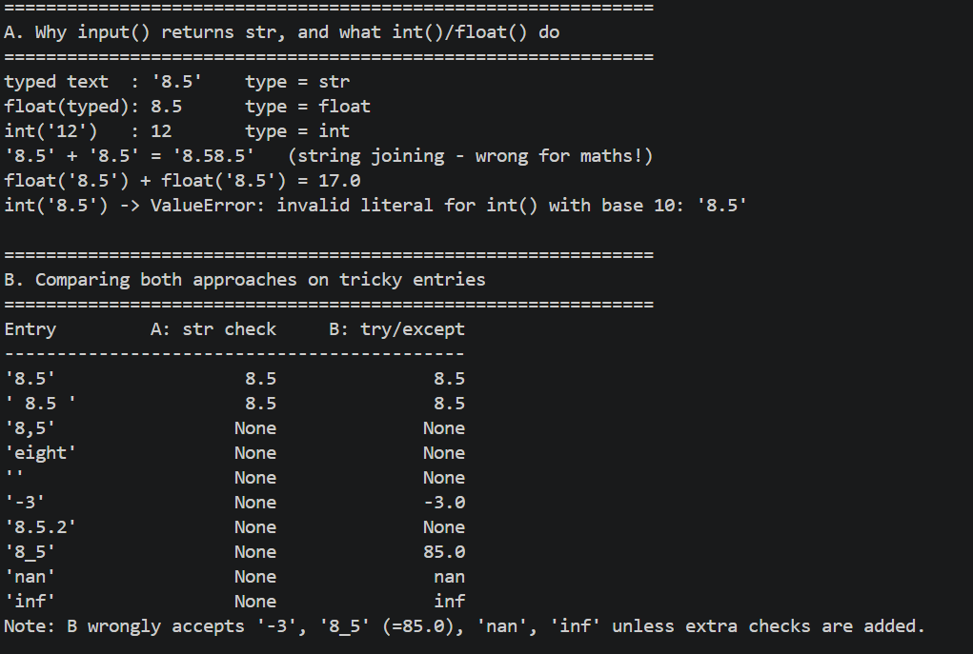
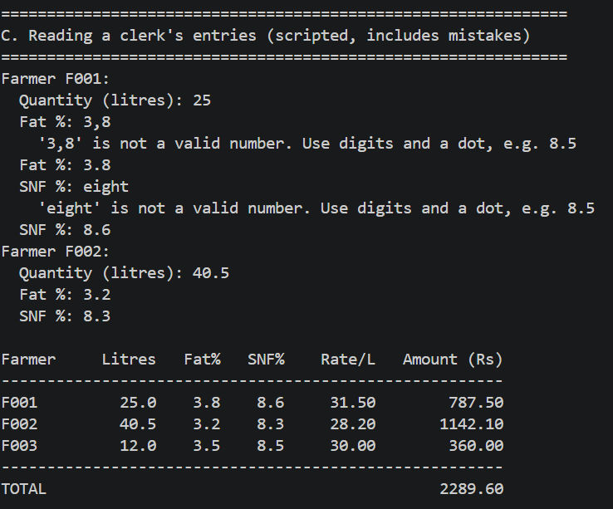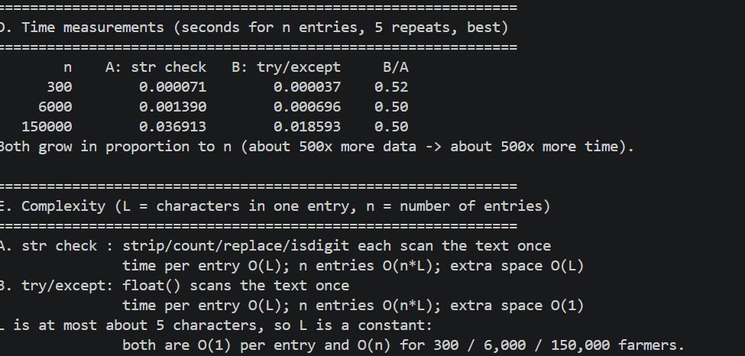

TASK 6
PROGRAM:
import timeit

BASE_PRICE = 30.00 # Rs per litre at 3.5% fat and 8.5% SNF
BASE_FAT = 3.5
BASE_SNF = 8.5
FAT_RATE = 0.40 # Rs per 0.1% fat above/below base
SNF_RATE = 0.30 # Rs per 0.1% SNF above/below base

def rate_per_litre(fat, snf):
"""Return the price in Rs for ONE litre of milk.

Parameters:
fat (float): fat percentage, e.g. 3.8
snf (float): SNF percentage, e.g. 8.6
Returns:
float: base price plus/minus the fat and SNF adjustments.
"""
fat_steps = round(fat * 10) - round(BASE_FAT * 10)
snf_steps = round(snf * 10) - round(BASE_SNF * 10)
return BASE_PRICE + fat_steps * FAT_RATE + snf_steps * SNF_RATE

def payout(qty, fat, snf):
"""Return the payment in Rs for ONE delivery, rounded to the paisa.

Parameters:
qty (float): litres delivered
fat (float): fat percentage
snf (float): SNF percentage
Returns:
float: qty * rate_per_litre(fat, snf), rounded to 2 decimals.
"""
return round(qty * rate_per_litre(fat, snf), 2)

def ten_day_total(entries):
"""Return the total payment in Rs for one farmer's deliveries.

Parameters:
entries (list): list of (qty, fat, snf) tuples, one per delivery
Returns:
float: sum of every payout(), rounded to 2 decimals.
"""
total = 0.0
for qty, fat, snf in entries:
total += payout(qty, fat, snf)
return round(total, 2)

def statement_line(name, qty, fat, snf):
"""Return (not print) one formatted statement line as a string.

Parameters:
name (str): farmer id
qty, fat, snf (float): the delivery
Returns:
str: an aligned line, ready for the caller to print or save.
"""
return (f"{name:<6}{qty:>8.1f}{fat:>6.1f}{snf:>6.1f}"
f"{rate_per_litre(fat, snf):>9.2f}{payout(qty, fat, snf):>11.2f}")

def payout_prints_only(qty, fat, snf):
"""BAD STYLE (for demonstration): shows the amount but returns None."""
print(f" (printed inside) amount = {payout(qty, fat, snf):.2f}")

def demo_return_vs_print():
print("=" * 62)
print("A. return versus print")
print("=" * 62)
result = payout_prints_only(25, 3.8, 8.6)
print(" value kept by caller:", result, "-> nothing to add or reuse")
kept = payout(25, 3.8, 8.6)
print(" value kept by caller:", kept, "-> can be added, stored, tested")
print(" doubled:", kept * 2)

def read_global():
"""Reading a global constant inside a function is allowed."""
return BASE_PRICE + 1 # BASE_PRICE is found in the global scope

def local_shadow():
"""Assigning to a name inside a function creates a NEW local variable."""
BASE_PRICE = 99.0 # local only; the global is untouched
return BASE_PRICE

def broken_update():
"""Reads and then assigns the same name: Python treats it as local."""
BASE_PRICE = BASE_PRICE + 1 # UnboundLocalError when called
return BASE_PRICE

def demo_scope():
print()
print("=" * 62)
print("B. Local and global names")
print("=" * 62)
print(" read_global() ->", read_global(), " (global read works)")
print(" local_shadow() ->", local_shadow(), " (local copy)")
print(" global BASE_PRICE still =", BASE_PRICE, "(unchanged)")
try:
broken_update()
except UnboundLocalError as err:
print(" broken_update() -> UnboundLocalError:", err)
print(" Rule: read rate constants freely; never assign to them inside a")
print(" function. Change a rate only in the constants block at the top.")

def demo_docstrings():
print()
print("=" * 62)
print("C. Docstrings (first line of each function)")
print("=" * 62)
for func in (rate_per_litre, payout, ten_day_total, statement_line):
print(f" {func.__name__:<15}: {func.__doc__.strip().splitlines()[0]}")

DELIVERIES = [ # one farmer, 10 days, 2 deliveries a day (sample of 6)
(25.0, 3.8, 8.6),
(22.5, 3.6, 8.5),
(30.0, 3.5, 8.5),
(18.0, 3.2, 8.3),
(27.5, 4.0, 8.8),
(21.0, 3.4, 8.4),
]

def demo_statement():
print()
print("=" * 62)
print("D. Ten-day statement for farmer F001")
print("=" * 62)
print(f"{'Farmer':<6}{'Litres':>8}{'Fat%':>6}{'SNF%':>6}{'Rate/L':>9}{'Amount':>11}")
print("-" * 46)
for qty, fat, snf in DELIVERIES:
print(statement_line("F001", qty, fat, snf))
print("-" * 46)
print(f"{'TOTAL':<6}{'':>29}{ten_day_total(DELIVERIES):>11.2f}")

NO_FUNCTION_SCRIPT = """
total = 0.0
for qty, fat, snf in DELIVERIES:
fat_steps = round(fat * 10) - round(BASE_FAT * 10)
snf_steps = round(snf * 10) - round(BASE_SNF * 10)
rate = BASE_PRICE + fat_steps * FAT_RATE + snf_steps * SNF_RATE
total += round(qty * rate, 2)
total = round(total, 2)
"""

# (b) Lambda expressions: same logic, short, but anonymous and no docstring.
rate_lambda = lambda fat, snf: (BASE_PRICE
+ (round(fat * 10) - round(BASE_FAT * 10)) * FAT_RATE
+ (round(snf * 10) - round(BASE_SNF * 10)) * SNF_RATE)
payout_lambda = lambda qty, fat, snf: round(qty * rate_lambda(fat, snf), 2)

def total_lambda(entries):
return round(sum(payout_lambda(q, f, s) for q, f, s in entries), 2)

def total_inline(entries):
"""Same maths with every call written inline (no helper-function calls)."""
total = 0.0
for qty, fat, snf in entries:
rate = (BASE_PRICE
+ (round(fat * 10) - round(BASE_FAT * 10)) * FAT_RATE
+ (round(snf * 10) - round(BASE_SNF * 10)) * SNF_RATE)
total += round(qty * rate, 2)
return round(total, 2)

def demo_alternatives():
print()
print("=" * 62)
print("E. Alternatives give the same answer")
print("=" * 62)
namespace = dict(globals())
exec(NO_FUNCTION_SCRIPT, namespace) # run the no-function script
results = {
"functions": ten_day_total(DELIVERIES),
"no-function script": namespace["total"],
"lambda": total_lambda(DELIVERIES),
"inline loop": total_inline(DELIVERIES),
}
for label, value in results.items():
print(f" {label:<20}: {value:>10.2f}")
print(" all equal:", len(set(results.values())) == 1)
print()
print(" Repeated code if rates are needed in 3 places (e.g. entry,")
print(" statement, audit): functions = 1 copy of the formula,")
print(" no-function script = 3 copies (a rate change can be missed in one).")

def measure_time():
print()
print("=" * 62)
print("F. Time for n deliveries (seconds, best of 5)")
print("=" * 62)
print(f"{'n':>9}{'functions':>12}{'inline':>12}{'lambda':>12}{'func/inline':>13}")
for n in (300, 6000, 150000):
data = (DELIVERIES * (n // len(DELIVERIES) + 1))[:n]
t_func = min(timeit.repeat(lambda: ten_day_total(data), number=1, repeat=5))
t_inl = min(timeit.repeat(lambda: total_inline(data), number=1, repeat=5))
t_lam = min(timeit.repeat(lambda: total_lambda(data), number=1, repeat=5))
print(f"{n:>9}{t_func:>12.6f}{t_inl:>12.6f}{t_lam:>12.6f}{t_func / t_inl:>13.2f}")

def explain_complexity():
print()
print("=" * 62)
print("G. Complexity")
print("=" * 62)
print(" rate_per_litre, payout : O(1) time, O(1) space")
print(" ten_day_total : O(n) time, O(1) extra space")
print(" inline / lambda : O(n) time, O(1) extra space (same)")
print(" A function call adds a small CONSTANT cost per call, so the")
print(" growth is still O(n); only the constant factor changes.")
print(" Measured above: functions are only about 10% slower than inline")
print(" (the f/i column), i.e. a few thousandths of a second extra for")
print(" 150,000 farmers, so clarity and reuse outweigh the overhead.")

def main():
demo_return_vs_print()
demo_scope()
demo_docstrings()
demo_statement()
demo_alternatives()
measure_time()
explain_complexity()

if __name__ == "__main__":
main()
OUTPUT:
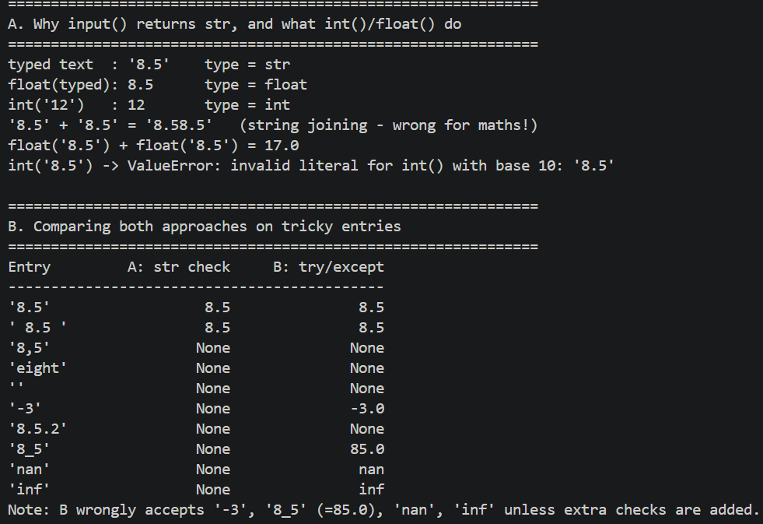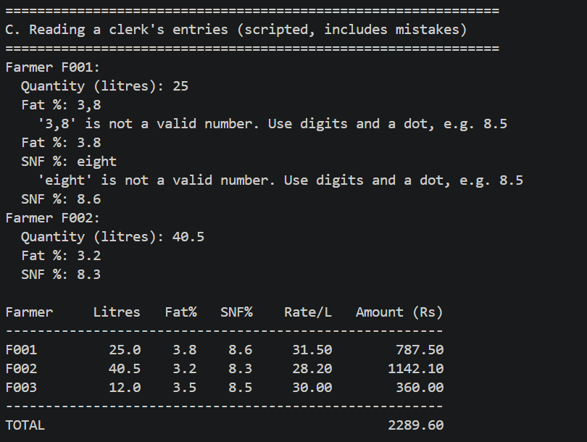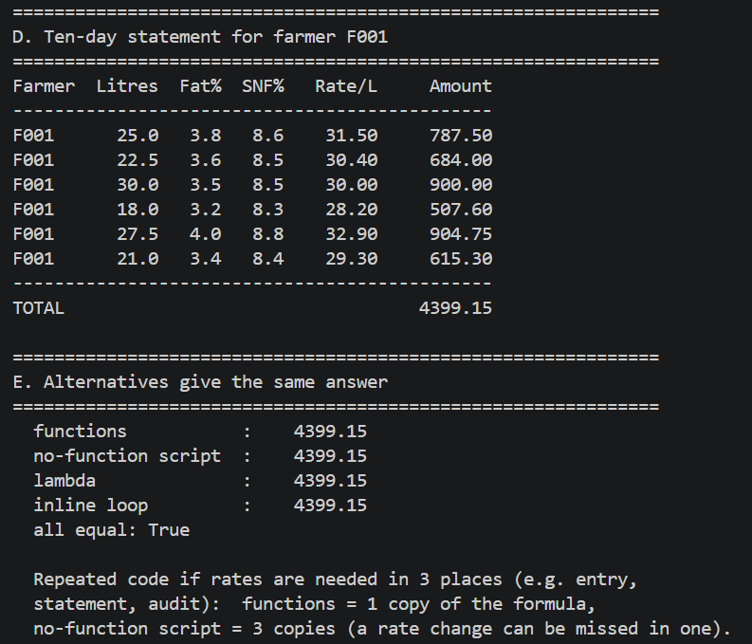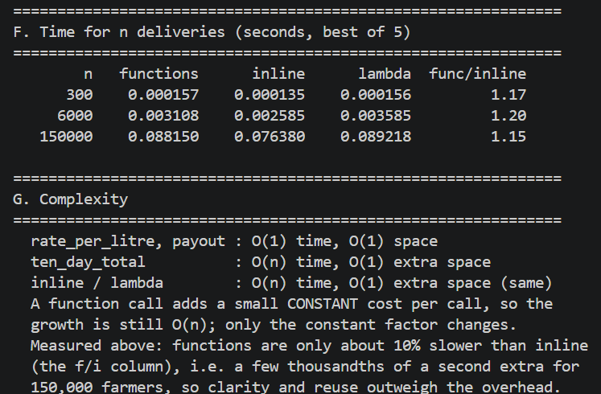

TASK 7
PROGRAM:
MILK RATE:
BASE_RATE = 30.00
FAT_STEP_VALUE = 0.40
SNF_STEP_VALUE = 0.30

def rate_per_litre(fat, snf):
"""Return the milk rate per litre based on fat and SNF values."""
fat_steps = round((fat - 3.5) / 0.1)
snf_steps = round((snf - 8.5) / 0.1)
rate = BASE_RATE + (fat_steps * FAT_STEP_VALUE) + (snf_steps * SNF_STEP_VALUE)
return round(rate, 2)

def payout(litres, fat, snf):
"""Return the total payment for the given quantity of milk."""
rate = rate_per_litre(fat, snf)
return round(rate * litres, 2)

if __name__ == "__main__":
examples = [
(10, 3.5, 8.5),
(8.5, 4.2, 8.7),
(12, 3.1, 8.3),
]

print(f"{'Litres':>8} {'Fat':>6} {'SNF':>6} {'Rate/Litre':>12} {'Payout':>10}")
print("-" * 48)
for litres, fat, snf in examples:
rate = rate_per_litre(fat, snf)
amount = payout(litres, fat, snf)
print(f"{litres:8.1f} {fat:6.1f} {snf:6.1f} ₹{rate:10.2f} ₹{amount:8.2f}")

TEST:
import milkrate

print("Testing the milk rate module")

rate = milkrate.rate_per_litre(4.2, 8.7)
amount = milkrate.payout(8.5, 4.2, 8.7)

print(f"Rate per litre: ₹{rate:.2f}")
print(f"Total payout: ₹{amount:.2f}")

OUTPUT :
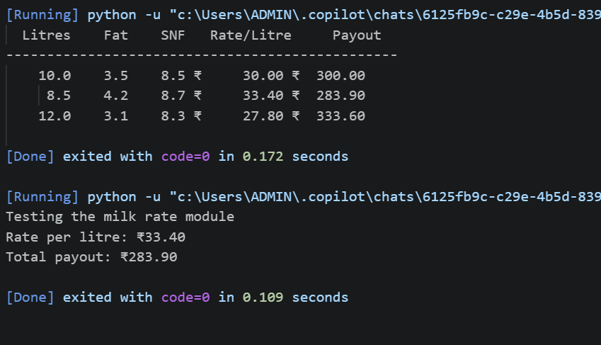

TASK 8
PROGRAM:
import math

# ---------- Constants ----------
DAYS = 10
MAX_LITRES = 200.0
MIN_FAT = 3.0
MAX_FAT = 8.0

# ---------- Functions ----------
def get_rate(fat):
"""Return the price per litre for a given fat percentage."""
if fat < 3.5:
return 25.00
elif fat < 4.5:
return 30.00
else:
return 35.00

def is_valid(litres, fat):
"""Return True only if litres and fat are inside the allowed range."""
return 0 < litres <= MAX_LITRES and MIN_FAT <= fat <= MAX_FAT

def calculate_payment(litres, fat):
"""Return the payment for one day, rounded to 2 decimals."""
return round(litres * get_rate(fat), 2)

def read_number(prompt):
"""Keep asking until the user types a real, finite number."""
while True:
text = input(prompt).strip()
try:
value = float(text)
except ValueError:
print(" Invalid input: please enter a number.")
continue
if not math.isfinite(value):
print(" Invalid input: please enter a normal number.")
continue
return value

def read_entry(day):
"""Read and validate one day's entry; repeat until it is valid."""
while True:
litres = read_number(f"Day {day} - milk in litres: ")
fat = read_number(f"Day {day} - fat percentage: ")
if is_valid(litres, fat):
return litres, fat
print(f" Invalid entry: litres must be above 0 and at most {MAX_LITRES:g}, "
f"fat must be between {MIN_FAT} and {MAX_FAT}. Please re-enter.")

def main():
total = 0.0
entries = [] # kept so a full statement can be printed

print("=== Village Milk Co-operative - Ten-Day Payment ===")
for day in range(1, DAYS + 1):
litres, fat = read_entry(day)
rate = get_rate(fat)
payment = calculate_payment(litres, fat)
total = round(total + payment, 2)
entries.append((day, litres, fat, rate, payment))

print("\n--------------- Payment Statement ---------------")
print(f"{'Day':<5}{'Litres':>9}{'Fat %':>8}{'Rate':>8}{'Payment':>12}")
for day, litres, fat, rate, payment in entries:
print(f"{day:<5}{litres:>9.2f}{fat:>8.2f}{rate:>8.2f}{payment:>12.2f}")
print("-------------------------------------------------")
print(f"Ten-day total payment: Rs. {total:.2f}")

if __name__ == "__main__":
try:
main()
except (KeyboardInterrupt, EOFError):
print("\nProgram stopped by the user.")

OUTPUT:
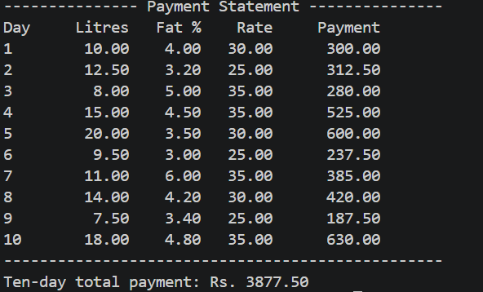

TASK 9
PROGRAM:
import math

# ---------------- Constants ----------------
DAYS = 10
STD_FAT = 3.5
STD_SNF = 8.5
BASE_RATE = 30.00 # Rs per litre at standard fat and SNF
FAT_STEP = 5.00 # Rs per litre for each 1 % fat above/below standard
SNF_STEP = 2.50 # Rs per litre for each 1 % SNF above/below standard
MAX_LITRES = 200.0
MIN_FAT, MAX_FAT = 3.0, 8.0
MIN_SNF, MAX_SNF = 7.0, 10.0

# ---------------- Core functions ----------------
def parse_number(text):
"""Convert text to a finite float. Return None if it is not a real number."""
try:
value = float(str(text).strip())
except ValueError:
return None
if not math.isfinite(value):
return None
return value

def is_valid(litres, fat, snf):
"""Return True only if litres, fat and SNF are all inside the allowed range."""
if litres is None or fat is None or snf is None:
return False
return (0 < litres <= MAX_LITRES
and MIN_FAT <= fat <= MAX_FAT
and MIN_SNF <= snf <= MAX_SNF)

def get_rate(fat, snf):
"""Return the price per litre for the given fat % and SNF %."""
rate = BASE_RATE + FAT_STEP * (fat - STD_FAT) + SNF_STEP * (snf - STD_SNF)
return round(rate, 2)

def calculate_payment(litres, fat, snf):
"""Return the payment for one day, rounded to 2 decimals."""
return round(litres * get_rate(fat, snf), 2)

def total_payment(entries):
"""Return the total for a list of (litres, fat, snf) entries."""
total = 0.0
for litres, fat, snf in entries:
total = round(total + calculate_payment(litres, fat, snf), 2)
return total

# ---------------- Input handling ----------------
def read_number(prompt):
"""Keep asking until the user types a real, finite number."""
while True:
value = parse_number(input(prompt))
if value is not None:
return value
print(" Invalid input: please enter a number.")

def read_entry(day):
"""Read and validate one day's entry; repeat until it is valid."""
while True:
litres = read_number(f"Day {day} - milk in litres: ")
fat = read_number(f"Day {day} - fat percentage: ")
snf = read_number(f"Day {day} - SNF percentage: ")
if is_valid(litres, fat, snf):
return litres, fat, snf
print(f" Invalid entry: litres must be above 0 and at most {MAX_LITRES:g}, "
f"fat {MIN_FAT}-{MAX_FAT}, SNF {MIN_SNF}-{MAX_SNF}. Please re-enter.")

def run_calculator():
total = 0.0
records = []
print("\n=== Village Milk Co-operative - Ten-Day Payment ===")
for day in range(1, DAYS + 1):
litres, fat, snf = read_entry(day)
rate = get_rate(fat, snf)
payment = calculate_payment(litres, fat, snf)
total = round(total + payment, 2)
records.append((day, litres, fat, snf, rate, payment))

print("\n------------------- Payment Statement -------------------")
print(f"{'Day':<5}{'Litres':>9}{'Fat %':>8}{'SNF %':>8}{'Rate':>9}{'Payment':>12}")
for day, litres, fat, snf, rate, payment in records:
print(f"{day:<5}{litres:>9.2f}{fat:>8.2f}{snf:>8.2f}{rate:>9.2f}{payment:>12.2f}")
print("----------------------------------------------------------")
print(f"Ten-day total payment: Rs. {total:.2f}")

# ---------------- Automated tests (assert based) ----------------
def run_tests():
"""Run every test case, print an expected-vs-actual table, then a summary."""
results = []

def check(label, case_input, expected, actual):
"""assert that actual equals expected; record PASS/FAIL without stopping."""
try:
if isinstance(expected, float):
assert abs(actual - expected) < 0.005, "value mismatch"
else:
assert actual == expected, "value mismatch"
status = "PASS"
except AssertionError:
status = "FAIL"
results.append((label, case_input, expected, actual, status))

# ---- Normal entries: (litres, fat, snf, expected payment) ----
normal = [
("N1 fat above std", 10, 4.00, 8.5, 325.00),
("N2 fat below std", 10, 3.25, 8.5, 287.50),
("N3 SNF above std", 10, 3.5, 9.0, 312.50),
("N4 SNF below std", 10, 3.5, 8.0, 287.50),
("N5 fat+SNF both above", 10, 4.00, 9.0, 337.50),
("N6 fat+SNF both below", 10, 3.25, 8.0, 275.00),
]
for label, l, f, s, exp in normal:
check(label, f"{l} L, fat {f}, SNF {s}", exp, calculate_payment(l, f, s))

# ---- Boundary entries ----
boundary = [
("B1 exactly 3.5 fat & 8.5 SNF", 10, 3.5, 8.5, 300.00),
("B2 lowest fat 3.0", 10, 3.0, 8.5, 275.00),
("B3 highest fat 8.0", 10, 8.0, 8.5, 525.00),
("B4 lowest SNF 7.0", 10, 3.5, 7.0, 262.50),
("B5 highest SNF 10.0", 10, 3.5, 10.0, 337.50),
("B6 highest litres 200", 200, 3.5, 8.5, 6000.00),
]
for label, l, f, s, exp in boundary:
check(label + " (rate x litres)", f"{l} L, fat {f}, SNF {s}",
exp, calculate_payment(l, f, s))
check(label + " (accepted?)", f"{l} L, fat {f}, SNF {s}",
True, is_valid(l, f, s))

# ---- Invalid entries (is_valid must be False / parse must be None) ----
check("I1 text 'abc' as litres", "'abc'", None, parse_number("abc"))
check("I2 text 'nan' as litres", "'nan'", None, parse_number("nan"))
check("I3 empty text", "''", None, parse_number(""))
check("I4 negative litres", "-5 L, fat 4.0, SNF 8.5", False, is_valid(-5, 4.0, 8.5))
check("I5 zero litres", "0 L, fat 4.0, SNF 8.5", False, is_valid(0, 4.0, 8.5))
check("I6 litres above 200", "200.5 L, fat 4.0, SNF 8.5", False, is_valid(200.5, 4.0, 8.5))
check("I7 fat below 3.0", "10 L, fat 2.9, SNF 8.5", False, is_valid(10, 2.9, 8.5))
check("I8 fat above 8.0", "10 L, fat 8.1, SNF 8.5", False, is_valid(10, 8.1, 8.5))
check("I9 SNF below 7.0", "10 L, fat 4.0, SNF 6.9", False, is_valid(10, 4.0, 6.9))
check("I10 SNF above 10.0", "10 L, fat 4.0, SNF 10.1", False, is_valid(10, 4.0, 10.1))

# ---- Five entries with a hand-calculated total ----
five = [
(10, 3.5, 8.5), # rate 30.00 -> 300.00
(10, 4.0, 8.5), # rate 32.50 -> 325.00
(20, 3.0, 8.5), # rate 27.50 -> 550.00
(10, 3.5, 9.0), # rate 31.25 -> 312.50
(8, 4.5, 8.0), # rate 33.75 -> 270.00
]
check("T1 five-entry total (hand = 1757.50)", "5 entries", 1757.50, total_payment(five))

# ---- Print the table ----
print("\n" + "=" * 106)
print(f"{'Case':<46}{'Input':<28}{'Expected':>12}{'Actual':>12}{'Result':>8}")
print("=" * 106)
for label, case_input, expected, actual, status in results:
print(f"{label:<46}{case_input:<28}{str(expected):>12}{str(actual):>12}{status:>8}")
print("=" * 106)
passed = sum(1 for r in results if r[4] == "PASS")
print(f"Tests run: {len(results)} Passed: {passed} Failed: {len(results) - passed}")
return passed == len(results)

# ---------------- Menu ----------------
def main():
while True:
print("\n1. Run payment calculator")
print("2. Run automated tests")
print("3. Exit")
choice = input("Enter your choice (1-3): ").strip()
if choice == "1":
run_calculator()
elif choice == "2":
run_tests()
elif choice == "3":
print("Goodbye.")
break
else:
print(" Invalid choice: please type 1, 2 or 3.")

if __name__ == "__main__":
try:
main()
except (KeyboardInterrupt, EOFError):
print("\nProgram stopped by the user.")

OUTPUT:
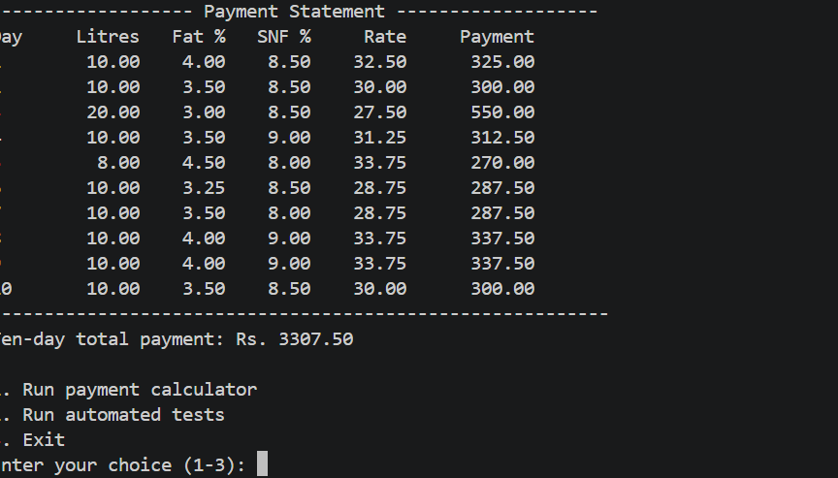

TASK 10
PROGRAM:
import random
import sys
import time
import tracemalloc
from decimal import Decimal, ROUND_HALF_UP

SIZES = [300, 6000, 150000]
REPEATS = 5 # each timing is the best of 5 runs
PAISE = Decimal("0.01")

D_BASE, D_FAT_STEP, D_SNF_STEP = Decimal("30"), Decimal("5"), Decimal("2.5")
D_STD_FAT, D_STD_SNF = Decimal("3.5"), Decimal("8.5")
F_BASE, F_FAT_STEP, F_SNF_STEP = 30.0, 5.0, 2.5
F_STD_FAT, F_STD_SNF = 3.5, 8.5

# ---------------------------------------------------------------- data
def make_data(count, seed=2026):
"""Return (float_entries, decimal_entries) built from the same text values."""
rng = random.Random(seed)
f_list, d_list = [], []
for _ in range(count):
lit = rng.randint(500, 6000) # 5.00 to 60.00 litres
fat = rng.randint(30, 80) # 3.0 to 8.0
snf = rng.randint(70, 100) # 7.0 to 10.0
lit_s = f"{lit // 100}.{lit % 100:02d}"
fat_s = f"{fat // 10}.{fat % 10}"
snf_s = f"{snf // 10}.{snf % 10}"
f_list.append((float(lit_s), float(fat_s), float(snf_s)))
d_list.append((Decimal(lit_s), Decimal(fat_s), Decimal(snf_s)))
return f_list, d_list

# ---------------------------------------------------------------- rates
def rate_float(fat, snf):
return round(F_BASE + F_FAT_STEP * (fat - F_STD_FAT) + F_SNF_STEP * (snf - F_STD_SNF), 2)

def rate_decimal(fat, snf):
return D_BASE + D_FAT_STEP * (fat - D_STD_FAT) + D_SNF_STEP * (snf - D_STD_SNF)

# ---------------------------------------------------------------- four totals
def float_round_each(entries):
total = 0.0
for litres, fat, snf in entries:
total += round(litres * rate_float(fat, snf), 2)
return total

def float_round_total(entries):
total = 0.0
for litres, fat, snf in entries:
total += litres * rate_float(fat, snf)
return round(total, 2)

def decimal_round_each(entries):
total = Decimal("0")
for litres, fat, snf in entries:
total += (litres * rate_decimal(fat, snf)).quantize(PAISE, rounding=ROUND_HALF_UP)
return total

def decimal_round_total(entries):
total = Decimal("0")
for litres, fat, snf in entries:
total += litres * rate_decimal(fat, snf)
return total.quantize(PAISE, rounding=ROUND_HALF_UP)

# ---------------------------------------------------------------- timing
def best_time(func, *args):
"""Return (result, best time in seconds) over REPEATS runs, using perf_counter."""
best, result = None, None
for _ in range(REPEATS):
start = time.perf_counter()
result = func(*args)
elapsed = time.perf_counter() - start
if best is None or elapsed < best:
best = elapsed
return result, best

# ---------------------------------------------------------------- Part A, B, C
def parts_abc():
all_f, all_d = make_data(max(SIZES))
rows = []
for n in SIZES:
f_entries, d_entries = all_f[:n], all_d[:n]
fe, t_fe = best_time(float_round_each, f_entries)
ft, t_ft = best_time(float_round_total, f_entries)
de, t_de = best_time(decimal_round_each, d_entries)
dt, t_dt = best_time(decimal_round_total, d_entries)

# how many single payments differ between float and Decimal rounding?
mism = 0
for (lf, ff, sf), (ld, fd, sd) in zip(f_entries, d_entries):
p_f = Decimal(str(round(lf * rate_float(ff, sf), 2)))
p_d = (ld * rate_decimal(fd, sd)).quantize(PAISE, rounding=ROUND_HALF_UP)
if p_f != p_d:
mism += 1
rows.append((n, fe, ft, de, dt, t_fe, t_ft, t_de, t_dt, mism))

print("=" * 96)
print("PART A - TOTALS (Rs). Reference = Decimal, each payment rounded half-up to the paisa")
print("=" * 96)
for n, fe, ft, de, dt, *_ in rows:
print(f"\nn = {n:,} payments")
print(f" Decimal, round each payment : {de} <- reference (bank amount)")
print(f" Decimal, round total only : {dt} diff from reference = {dt - de}")
print(f" float, round each payment : {fe!r}")
print(f" as 2-decimal money : {fe:.2f} diff from reference = {Decimal(f'{fe:.2f}') - de}")
print(f" raw float error : {Decimal(fe) - de}")
print(f" float, round total only : {ft!r} diff from reference = {Decimal(f'{ft:.2f}') - de}")

print("\n" + "=" * 96)
print("PART C - single payments that differ (float round() vs Decimal half-up)")
print("=" * 96)
for n, *_, mism in rows:
print(f" n = {n:>7,}: {mism:>5,} payments differ by 1 paisa ({100 * mism / n:.2f} %)")

print("\n" + "=" * 96)
print(f"PART B - TIME (seconds, best of {REPEATS} runs, time.perf_counter)")
print("=" * 96)
print(f"{'n':>9}{'float each':>14}{'float total':>14}{'Decimal each':>15}{'Decimal total':>15}{'Dec/float':>11}")
for n, _, _, _, _, t_fe, t_ft, t_de, t_dt, _ in rows:
print(f"{n:>9,}{t_fe:>14.6f}{t_ft:>14.6f}{t_de:>15.6f}{t_dt:>15.6f}{t_de / t_fe:>10.1f}x")

# ---------------------------------------------------------------- Part D
def demo_float_error():
print("\n" + "=" * 96)
print("WHY float DIFFERS - binary storage cannot hold most decimal fractions exactly")
print("=" * 96)
print(f" 0.1 + 0.1 + 0.1 = {0.1 + 0.1 + 0.1!r} (not 0.3)")
print(f" Decimal('0.1') x 3 = {Decimal('0.1') * 3}")
print(f" round(2.675, 2) [float] = {round(2.675, 2)} (2.675 is stored as 2.67499999...)")
print(f" Decimal('2.675') half-up = {Decimal('2.675').quantize(PAISE, rounding=ROUND_HALF_UP)}")

def recompute_float(entries):
total = 0.0
for litres, fat, snf in entries:
total += round(litres * rate_float(fat, snf), 2)
return total

def lookup_float(entries, table):
total = 0.0
for litres, fat, snf in entries:
total += round(litres * table[(fat, snf)], 2)
return total

def recompute_decimal(entries):
total = Decimal("0")
for litres, fat, snf in entries:
total += (litres * rate_decimal(fat, snf)).quantize(PAISE, rounding=ROUND_HALF_UP)
return total

def lookup_decimal(entries, table):
total = Decimal("0")
for litres, fat, snf in entries:
total += (litres * table[(fat, snf)]).quantize(PAISE, rounding=ROUND_HALF_UP)
return total

def part_d():
print("\n" + "=" * 96)
print("PART D - RATE TABLE (dictionary) vs RECALCULATING THE RATE")
print("=" * 96)
all_f, all_d = make_data(max(SIZES))
pairs_f = sorted({(f, s) for _, f, s in all_f})
pairs_d = sorted({(f, s) for _, f, s in all_d})
k = len(pairs_f)
print(f" Distinct (fat, snf) pairs actually used in 150,000 entries: k = {k:,}")
print(f" Largest possible k with 0.1 steps (51 fat x 31 SNF values): {51 * 31:,}")

# build the tables, measuring build time and extra memory
tracemalloc.start()
t0 = time.perf_counter()
table_f = {p: rate_float(*p) for p in pairs_f}
build_f = time.perf_counter() - t0
mem_f = tracemalloc.get_traced_memory()[0]
tracemalloc.stop()

tracemalloc.start()
t0 = time.perf_counter()
table_d = {p: rate_decimal(*p) for p in pairs_d}
build_d = time.perf_counter() - t0
mem_d = tracemalloc.get_traced_memory()[0]
tracemalloc.stop()

print(f"\n Build time : float table {build_f * 1000:.3f} ms, Decimal table {build_d * 1000:.3f} ms")
print(f" Extra memory: float table {mem_f / 1024:.1f} KiB, Decimal table {mem_d / 1024:.1f} KiB "
f"(about {mem_f / k:.0f} and {mem_d / k:.0f} bytes per pair)")

print(f"\n {'n':>9}{'method':>22}{'float (s)':>13}{'us/entry':>10}{'Decimal (s)':>14}{'us/entry':>10}")
for n in SIZES:
f_entries, d_entries = all_f[:n], all_d[:n]
rf, t_rf = best_time(recompute_float, f_entries)
lf, t_lf = best_time(lookup_float, f_entries, table_f)
rd, t_rd = best_time(recompute_decimal, d_entries)
ld, t_ld = best_time(lookup_decimal, d_entries, table_d)
assert rf == lf and rd == ld, "table and recalculation must give identical totals"
print(f" {n:>9,}{'recalculate':>22}{t_rf:>13.6f}{t_rf / n * 1e6:>10.3f}{t_rd:>14.6f}{t_rd / n * 1e6:>10.3f}")
print(f" {'':>9}{'table lookup':>22}{t_lf:>13.6f}{t_lf / n * 1e6:>10.3f}{t_ld:>14.6f}{t_ld / n * 1e6:>10.3f}")
print(f" {'':>9}{'speed-up (x)':>22}{t_rf / t_lf:>13.2f}{'':>10}{t_rd / t_ld:>14.2f}")
print("\n Check: table totals equal recalculated totals for every size (assert passed).")

# ---------------------------------------------------------------- main
def main():
print(f"Python {sys.version.split()[0]} sizes = {SIZES} repeats = {REPEATS}\n")
parts_abc()
demo_float_error()
part_d()

if __name__ == "__main__":
main()
OUTPUT: 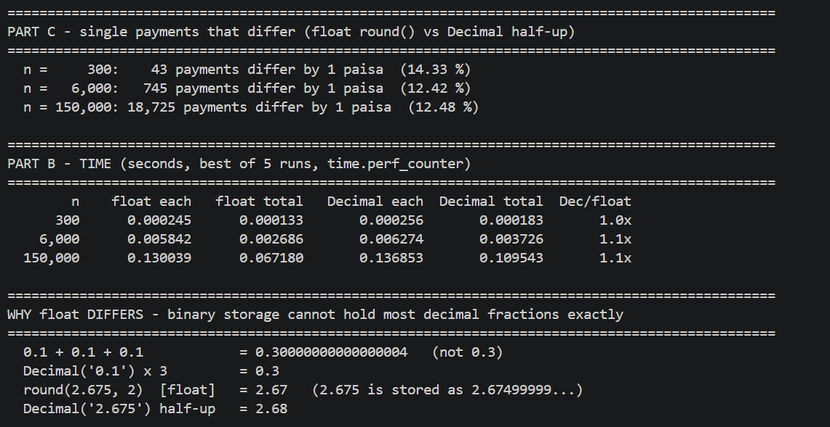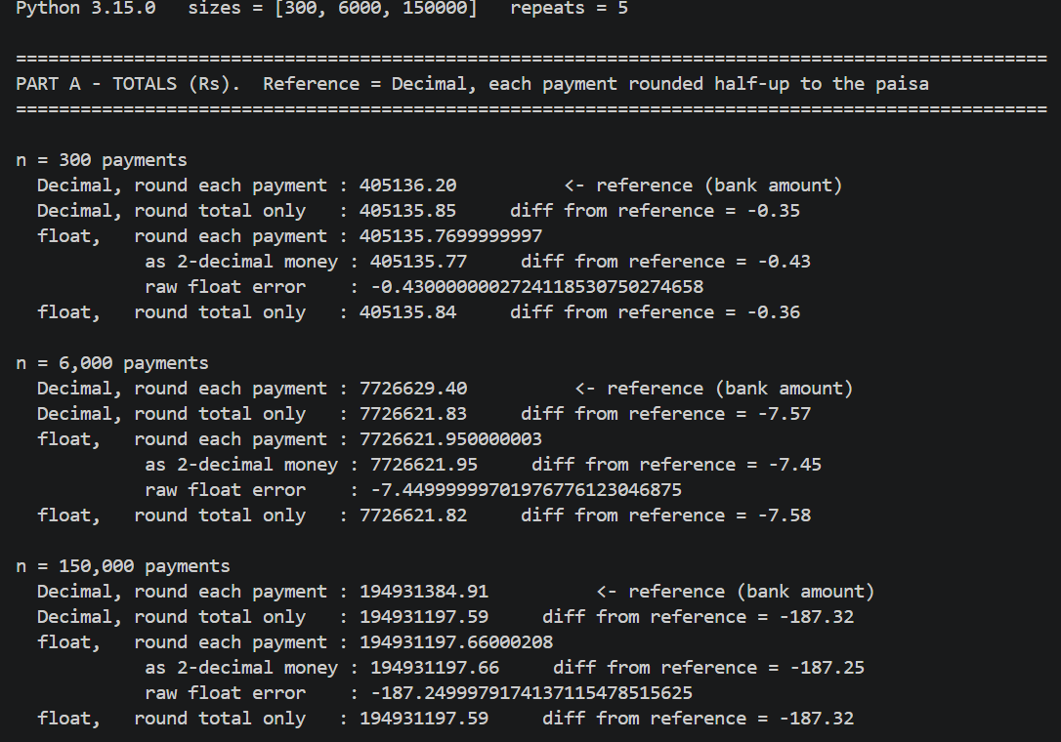
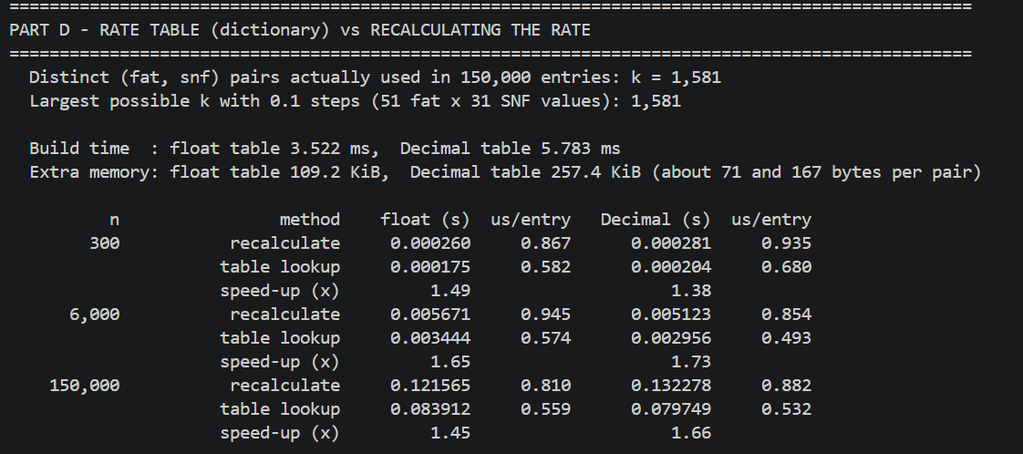

TASK 11
PROGRAM:
import json
import time
import tracemalloc
from decimal import Decimal, ROUND_HALF_UP
from pathlib import Path

RATE_FILE = Path("milkrate.json")

# Hard-coded rate card
HARDCODED_RATE_CARD = {
"base_rate": "20.00",
"fat_rate": "4.50",
"snf_rate": "1.00"
}

CENT = Decimal("0.01")

def money(value):
"""Round monetary values to 2 decimal places."""
return Decimal(str(value)).quantize(
CENT, rounding=ROUND_HALF_UP
)

def validate_inputs(farmer_id, litres, fat, snf, shift):
if not farmer_id.strip():
raise ValueError("Farmer ID cannot be empty.")
if Decimal(str(litres)) <= 0:
raise ValueError("Litres must be greater than zero.")
if not Decimal("0") <= Decimal(str(fat)) <= Decimal("100"):
raise ValueError("Fat percentage must be between 0 and 100.")
if not Decimal("0") <= Decimal(str(snf)) <= Decimal("100"):
raise ValueError("SNF percentage must be between 0 and 100.")
if shift.upper() not in ("MORNING", "EVENING"):
raise ValueError("Shift must be MORNING or EVENING.")

def calculate_payment(farmer_id, litres, fat, snf, shift, rate_card):
"""Calculate rate per litre and payment using Decimal."""
validate_inputs(farmer_id, litres, fat, snf, shift)

litres = Decimal(str(litres))
fat = Decimal(str(fat))
snf = Decimal(str(snf))

base = Decimal(str(rate_card["base_rate"]))
fat_rate = Decimal(str(rate_card["fat_rate"]))
snf_rate = Decimal(str(rate_card["snf_rate"]))

# Illustrative pricing formula
rate = money(base + (fat * fat_rate) + (snf * snf_rate))
amount = money(rate * litres)

return {
"farmer_id": farmer_id,
"shift": shift.upper(),
"litres": litres,
"fat": fat,
"snf": snf,
"rate": rate,
"amount": amount
}

def create_json_rate_card():
"""Create the file only if it does not already exist."""
if not RATE_FILE.exists():
with RATE_FILE.open("w", encoding="utf-8") as file:
json.dump(HARDCODED_RATE_CARD, file, indent=4)
print("Created milkrate.json with sample rates.")

def load_json_rate_card():
"""Read the rate card from a JSON file."""
with RATE_FILE.open("r", encoding="utf-8") as file:
data = json.load(file)

required = {"base_rate", "fat_rate", "snf_rate"}
if not isinstance(data, dict) or set(data) != required:
raise ValueError("JSON rate card has missing or extra keys.")

for key in required:
value = Decimal(str(data[key]))
if not value.is_finite() or value < 0:
raise ValueError(f"Invalid rate value: {key}")

return data

def calculate_ten_day_total(records, rate_card):
"""Calculate the total of payments for ten days."""
total = Decimal("0.00")

for record in records:
result = calculate_payment(
record["farmer_id"],
record["litres"],
record["fat"],
record["snf"],
record["shift"],
rate_card
)
total += result["amount"]

return money(total)

def benchmark(label, function, repeats=10000):
"""Measure execution time and peak traced memory."""
tracemalloc.start()
start = time.perf_counter()

for _ in range(repeats):
function()

elapsed = time.perf_counter() - start
current, peak = tracemalloc.get_traced_memory()
tracemalloc.stop()

print(f"{label}:")
print(f" Runs: {repeats}")
print(f" Total time: {elapsed:.6f} seconds")
print(f" Average time: {elapsed / repeats * 1_000_000:.3f} "
"microseconds per run")
print(f" Peak traced memory: {peak:,} bytes")

def main():
print("=" * 58)
print("TASK 11: FINAL DESIGN EVALUATION")
print("=" * 58)

create_json_rate_card()
json_rate_card = load_json_rate_card()

# One sample milk delivery
sample = {
"farmer_id": "F101",
"litres": "10.5",
"fat": "4.0",
"snf": "8.5",
"shift": "MORNING"
}

hardcoded_result = calculate_payment(
**sample, rate_card=HARDCODED_RATE_CARD
)
json_result = calculate_payment(
**sample, rate_card=json_rate_card
)

print("\n1. SAMPLE PAYMENT")
print("-" * 58)
print("Farmer ID:", hardcoded_result["farmer_id"])
print("Shift:", hardcoded_result["shift"])
print("Litres:", hardcoded_result["litres"])
print("Fat %:", hardcoded_result["fat"])
print("SNF %:", hardcoded_result["snf"])
print("Rate per litre: Rs.", hardcoded_result["rate"])
print("Payment: Rs.", hardcoded_result["amount"])

# Verify the two designs produce identical results
print("\n2. DESIGN CORRECTNESS TEST")
print("-" * 58)
assert hardcoded_result == json_result
print("PASS: Hard-coded and JSON designs give the same result.")

# Test half-up rounding
assert money("12.345") == Decimal("12.35")
assert money("12.344") == Decimal("12.34")
print("PASS: ROUND_HALF_UP works for the tested values.")

# Test invalid input
try:
calculate_payment(
"F101", "-2", "4.0", "8.5",
"MORNING", HARDCODED_RATE_CARD
)
raise AssertionError("Invalid litres were accepted.")
except ValueError:
print("PASS: Negative litres are rejected.")

# Test ten-day total
ten_day_records = [
{
"farmer_id": "F101",
"litres": "10",
"fat": "4.0",
"snf": "8.5",
"shift": "MORNING"
}
for _ in range(10)
]

ten_day_total = calculate_ten_day_total(
ten_day_records, HARDCODED_RATE_CARD
)
one_day = calculate_payment(
**ten_day_records[0], rate_card=HARDCODED_RATE_CARD
)["amount"]

assert ten_day_total == one_day * 10
print("PASS: Ten-day total matches the sum of daily payments.")
print("Ten-day total: Rs.", ten_day_total)

# Demonstrate rate revision without changing calculation code
revised_rate_card = dict(HARDCODED_RATE_CARD)
revised_rate_card["base_rate"] = "21.00"

revised_result = calculate_payment(
**sample, rate_card=revised_rate_card
)
print("\n3. RATE REVISION TEST")
print("-" * 58)
print("Original payment: Rs.", hardcoded_result["amount"])
print("Revised payment: Rs.", revised_result["amount"])
print("PASS: Changing the base rate changes the payment.")

# Benchmark repeated calculations using both designs
print("\n4. PERFORMANCE EXPERIMENT")
print("-" * 58)

benchmark(
"Hard-coded rate card calculation",
lambda: calculate_payment(
**sample, rate_card=HARDCODED_RATE_CARD
)
)

benchmark(
"JSON rate card calculation (file loaded once)",
lambda: calculate_payment(
**sample, rate_card=json_rate_card
)
)

# Measure file loading separately
benchmark(
"JSON file loading",
load_json_rate_card,
repeats=1000
)

print("\n5. FINAL RECOMMENDATION")
print("-" * 58)
print("Use Decimal for monetary calculations.")
print("Round the rate per litre to 2 decimal places")
print("using ROUND_HALF_UP, then round the payment to")
print("2 decimal places.")
print("For a small co-operative, JSON is easier to revise.")
print("For a district union, use validated configuration,")
print("a database, audit logs and automated tests.")
print("\nAll programmed tests passed.")

if __name__ == "__main__":
main()

OUTPUT:
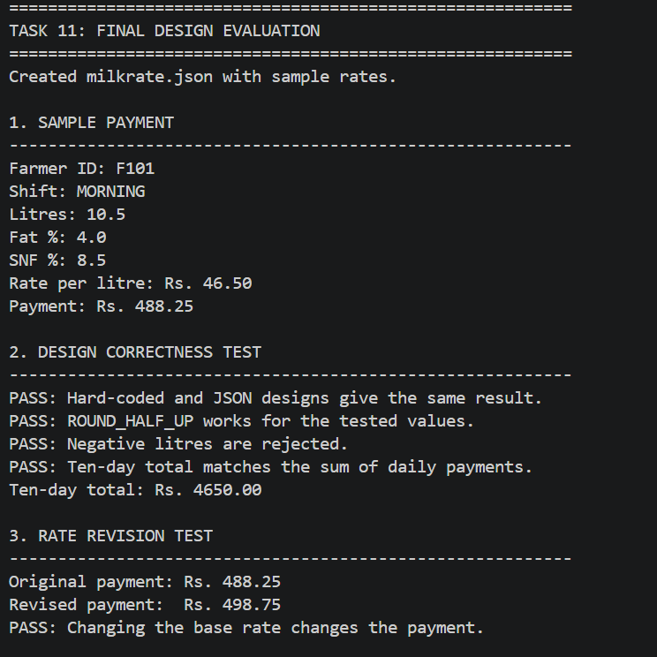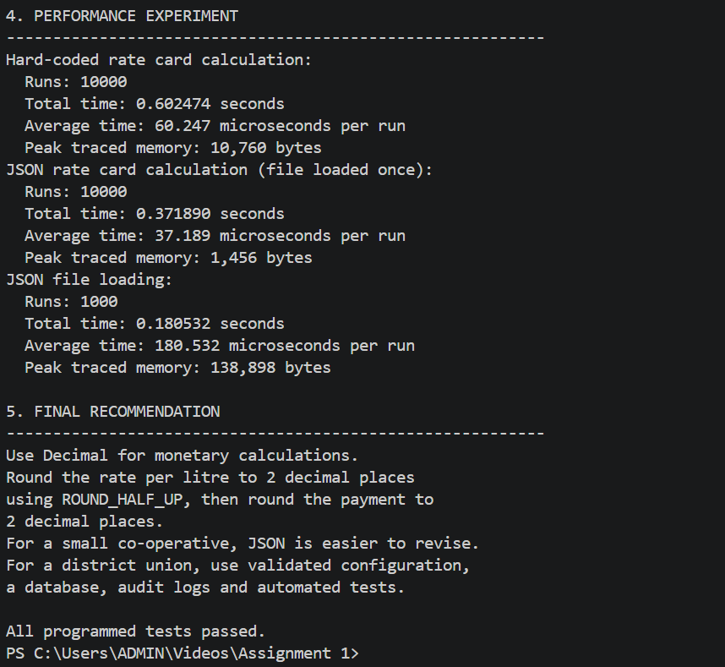

TASK 12
PROGRAM:
from decimal import Decimal, ROUND_HALF_UP
from datetime import date

ORIGINAL_RATES = {
"base_rate": Decimal("20.00"),
"fat_rate": Decimal("4.50"),
"snf_rate": Decimal("1.00")
}

# NEW SEASONAL RATE CARD: April to June
SEASONAL_RATES = {
"base_rate": Decimal("32.00"),
"fat_rate": Decimal("0.45"),
"snf_rate": Decimal("1.00")
}

# New bonus requirements
BONUS_RATE = Decimal("0.50")
BONUS_THRESHOLD = Decimal("500")

# Money is rounded to two decimal places
CENT = Decimal("0.01")

def money(value):
"""Round monetary values using ROUND_HALF_UP."""
return Decimal(str(value)).quantize(
CENT, rounding=ROUND_HALF_UP
)

def validate_readings(farmer_id, litres, fat, snf):
"""Validate farmer details and analyser readings."""
if not farmer_id or not farmer_id.strip():
raise ValueError("Farmer ID cannot be empty.")

litres = Decimal(str(litres))
fat = Decimal(str(fat))
snf = Decimal(str(snf))

if not litres.is_finite() or litres <= 0:
raise ValueError("Litres must be a positive number.")

if not fat.is_finite() or not Decimal("0") <= fat <= Decimal("100"):
raise ValueError("Fat must be between 0 and 100.")

if not snf.is_finite() or not Decimal("0") <= snf <= Decimal("100"):
raise ValueError("SNF must be between 0 and 100.")

return litres, fat, snf

# ------------------------------------------------------------
# SECTION A: IMPACT ANALYSIS
# ------------------------------------------------------------

def show_impact_analysis():
print("\n" + "=" * 65)
print("A. IMPACT ANALYSIS - 2 MARKS")
print("=" * 65)

print("1. Analyser readings now contain two decimal places.")
print("2. Seasonal base rate: Rs. 32.00 from April to June.")
print("3. Seasonal fat rate: Rs. 0.45 per fat percentage point.")
print("4. Bonus: Rs. 0.50 per litre when supply exceeds 500 litres")
print(" in ten days.")
print("5. Decimal is retained for accurate decimal arithmetic.")
print("6. Rate selection, payment calculation and ten-day total")
print(" functions must be updated.")

# ------------------------------------------------------------
# SECTION B: EVALUATION OF THE ORIGINAL DESIGN
# ------------------------------------------------------------

def select_rate_card(month):
"""Select seasonal or original rates using the month number."""
if not isinstance(month, int) or not 1 <= month <= 12:
raise ValueError("Month must be an integer from 1 to 12.")

if month in (4, 5, 6):
return SEASONAL_RATES

return ORIGINAL_RATES

def calculate_payment(farmer_id, litres, fat, snf, month):
"""
Calculate payment for one delivery.

Assumption: the fat rate applies per one percentage point
of fat, and the original SNF rate remains unchanged.
"""
litres, fat, snf = validate_readings(
farmer_id, litres, fat, snf
)

rates = select_rate_card(month)

# Calculate the rate before rounding the monetary rate.
raw_rate = (
rates["base_rate"]
+ fat * rates["fat_rate"]
+ snf * rates["snf_rate"]
)

rate_per_litre = money(raw_rate)
payment = money(rate_per_litre * litres)

return {
"farmer_id": farmer_id,
"litres": litres,
"fat": fat,
"snf": snf,
"month": month,
"rate": rate_per_litre,
"payment": payment
}

# ------------------------------------------------------------
# SECTION C: ADAPTED DESIGN - SEPARATE BONUS FUNCTION
# ------------------------------------------------------------

def calculate_bonus(total_litres):
"""Give a bonus only when supply is greater than 500 litres."""
total_litres = Decimal(str(total_litres))

if not total_litres.is_finite() or total_litres < 0:
raise ValueError("Total litres cannot be negative or invalid.")

if total_litres > BONUS_THRESHOLD:
return money(total_litres * BONUS_RATE)

return Decimal("0.00")

def calculate_ten_day_total(records, month):
"""
Calculate the ten-day payment and bonus.

Each record is a dictionary containing:
farmer_id, litres, fat and snf.
All records belong to the same farmer and ten-day period.
"""
total_litres = Decimal("0")
total_payment = Decimal("0.00")

for record in records:
result = calculate_payment(
record["farmer_id"],
record["litres"],
record["fat"],
record["snf"],
month
)

total_litres += result["litres"]
total_payment += result["payment"]

total_payment = money(total_payment)
bonus = calculate_bonus(total_litres)
final_total = money(total_payment + bonus)

return {
"total_litres": total_litres,
"milk_payment": total_payment,
"bonus": bonus,
"final_total": final_total
}

# ------------------------------------------------------------
# SECTION D: TESTS AND EVIDENCE-BASED DEFENCE
# ------------------------------------------------------------

def run_tests():
print("\n" + "=" * 65)
print("B. EVALUATION OF ORIGINAL DESIGN - 2 MARKS")
print("=" * 65)

sample = {
"farmer_id": "F101",
"litres": "10.00",
"fat": "4.25",
"snf": "8.65"
}

old_result = calculate_payment(**sample, month=1)
summer_result = calculate_payment(**sample, month=4)

print("\nWorked example: 10 litres, fat 4.25%, SNF 8.65%")
print("Original rate card (January):")
print(" Rate per litre: Rs.", old_result["rate"])
print(" Payment: Rs.", old_result["payment"])

print("Seasonal rate card (April):")
print(" Rate per litre: Rs.", summer_result["rate"])
print(" Payment: Rs.", summer_result["payment"])

print("\nOriginal functions remain useful, but the rate")
print("selection and bonus rules must be added.")

print("\n" + "=" * 65)
print("C. ADAPTATION / REDESIGN - 2 MARKS")
print("=" * 65)

print("Decision: MODIFY")
print("Retained: Decimal, validation and modular calculation.")
print("Added: Seasonal rate selection and bonus calculation.")
print("Changed: Ten-day total now includes the bonus.")

print("\n" + "=" * 65)
print("D. EVIDENCE-BASED DEFENCE - 2 MARKS")
print("=" * 65)

# Test 1: Both rate cards
assert old_result["rate"] == Decimal("47.78")
assert old_result["payment"] == Decimal("477.80")
assert summer_result["rate"] == Decimal("42.56")
assert summer_result["payment"] == Decimal("425.60")
print("PASS 1: Original and seasonal rates calculate correctly.")

# Test 2: No bonus at exactly 500 litres
assert calculate_bonus("500") == Decimal("0.00")
print("PASS 2: Exactly 500 litres receives no bonus.")

# Test 3: Bonus above threshold
assert calculate_bonus("501") == Decimal("250.50")
print("PASS 3: 501 litres receives a Rs. 250.50 bonus.")

# Test 4: Ten-day total including bonus
ten_day_records = [{
"farmer_id": "F101",
"litres": "501",
"fat": "4.25",
"snf": "8.65"
}]

total = calculate_ten_day_total(ten_day_records, month=4)

assert total["milk_payment"] == Decimal("21322.56")
assert total["bonus"] == Decimal("250.50")
assert total["final_total"] == Decimal("21573.06")

print("PASS 4: Ten-day total correctly includes the bonus.")
print(" Milk payment: Rs.", total["milk_payment"])
print(" Bonus: Rs.", total["bonus"])
print(" Final total: Rs.", total["final_total"])

# Test 5: Two-decimal readings and rounding
assert money("12.345") == Decimal("12.35")
print("PASS 5: Monetary ROUND_HALF_UP rounding works.")

# Test 6: Invalid inputs are rejected
try:
calculate_payment("F101", "-1", "4.25", "8.65", 4)
raise AssertionError("Negative litres were accepted.")
except ValueError:
print("PASS 6: Invalid litres are rejected.")

# Test 7: Seasonal boundaries
assert select_rate_card(3) == ORIGINAL_RATES
assert select_rate_card(4) == SEASONAL_RATES
assert select_rate_card(6) == SEASONAL_RATES
assert select_rate_card(7) == ORIGINAL_RATES
print("PASS 7: Seasonal boundaries (March, April, June, July).")

print("\nFINAL DEFENCE")
print("-" * 65)
print("MODIFY is appropriate because the original modular design")
print("can support the new requirements without a full rewrite.")
print("Decimal improves decimal arithmetic; separate functions")
print("make seasonal rates and bonus rules easier to test.")
print("Trade-off: more validation and rules increase code size.")
print("Production use requires the union's approved rate-step")
print("definition, official off-season rates and audit records.")

print("\nAll 7 tests passed successfully.")

def main():
print("=" * 65)
print("TASK 12: RE-EVALUATE AND ADAPT THE MILK PAYMENT DESIGN")
print("=" * 65)

show_impact_analysis()
run_tests()

if __name__ == "__main__":
main()

OUTPUT:
